***Case Study 4.1: Pizza ? Just eat !***

Two Piiza meals are shown in the following. Between the two examples lie about 1.5 years of user experience, and tuning the autoISF FCL using the emulator.

**Pizza w/ well tuned autoISF FCL** Bernie 08 Aug 2023 12-17h

Home-made Pizza, size of an European baking oven rack (ALDI Süd dough roll) with canned tomatoes, salami, mozarella, pre-fried eggplant, bell pepper, onions & garlic topping. I ate half of it for my ~12:15 h lunch.

FCL using Lyumjev (AAPS dev w/autoISF 2.2.8):The oref(1) SMB+UAM algo can deal very well with Pizza after autoISF gave 2 SMBs, together 4.8 U, at 12:33 + 12:38 PM.





No initial bolus given by me (1,2 U at 11:13 from automatic regulation towards the pre-lunch bg target of 74 mg/dl), and without any carb announcement.

Note that TT 74 is automatically again set at steep rise starting again around 14:10 h. With iob being back below iobTH then, 0.9 U of additional insulin is given (02:18 -02:23)

Another TT 74 is automatically set after the one **jumpy CGM value** around 14:30, leading to 1,7 U (02:38 PM) additional insulin due to the „fake“ strong rise. This is made the situation risky with respect to going a bit too low between 17 and 18 h, and I had to watch out whether I need a snack, or whether I just get to a nice low starting bg for my dinner.

PS: The yellow graph on bottom of diagram 1 is the "carb deviation": As I did not tell my loop what I ate, it tells me back (calculates), what I „must have consumed“ that would explain the glucose development (in light of the calculated insulin decay).

In autoISF 3.0, iobTH is set via an iobTH_percent of iobMAX in /Preferences

12:38 PM my iobTH was first time exceeded => Temp SMB shut-off, and "only" 500%TBR (graph 3, 12:34 - :44).

12:44 PM basla was reduced to zero for half an hour, for satey reasons and to watch the further glucose development

01:18 PM iob had fallen below iobTH again, as more carbs of my pizza had required insulin. . Die nächste große (2,3 U) SMB kam

At 01:18 PM the next big (2.3 U) SMB was triggered, and iobTH was exceeded again.

The zig-zag shaped blue iob curve (lower part of diagram 1) shows nicely, how – over many hours – the loop was able to keep up sufficient iob for digesting the pizza, without – thanks to my set iobTH - ever shooting up into iob levels that would be unsafe for me.

Overall, this ended up as a day with 99% TIR. *Logfiles: AndroidAPS._2023-08-08_00-00-08_ 8 ff*

**Pizza *before* all autoISF weights were *properly tuned*** *bernie 10 Feb 2022*

About 1.5 years earlier,I had used a „standardized“ commercial type of Pizza to determine the various ISF_weights.

*After this experience*, the conclusion was that my bgAccel_ISF_weight had to be strengthened, while pp_ISF- and deltaISF_weights needed to be softened for better results:

The testing meal

~ 12:30 PM: Wagner Veggie Pizza with extra ham + Mozzarella topping + red wine

15g fast carbs + 75 g other carbs + 34 g protein + 30 g fat

Very rapidly AAPS was building over 8 U of iob (graph on the left). Using about 6 U up (graph on the right) the glucose rise was within less than an hour after starting to eat in control. After over an hour pause, more SMBs were fired after 03 PM, as more carbs came to absorption from this greasy meal:

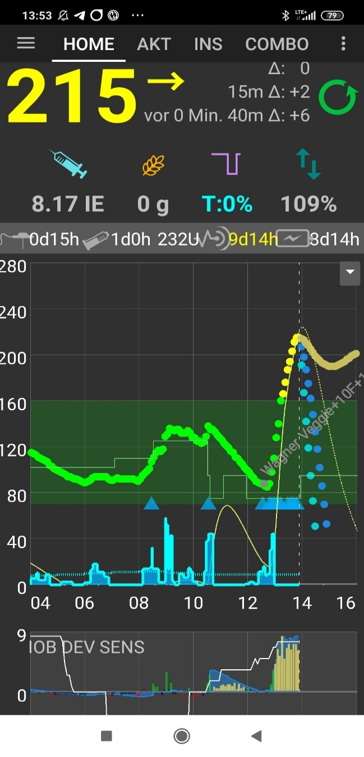

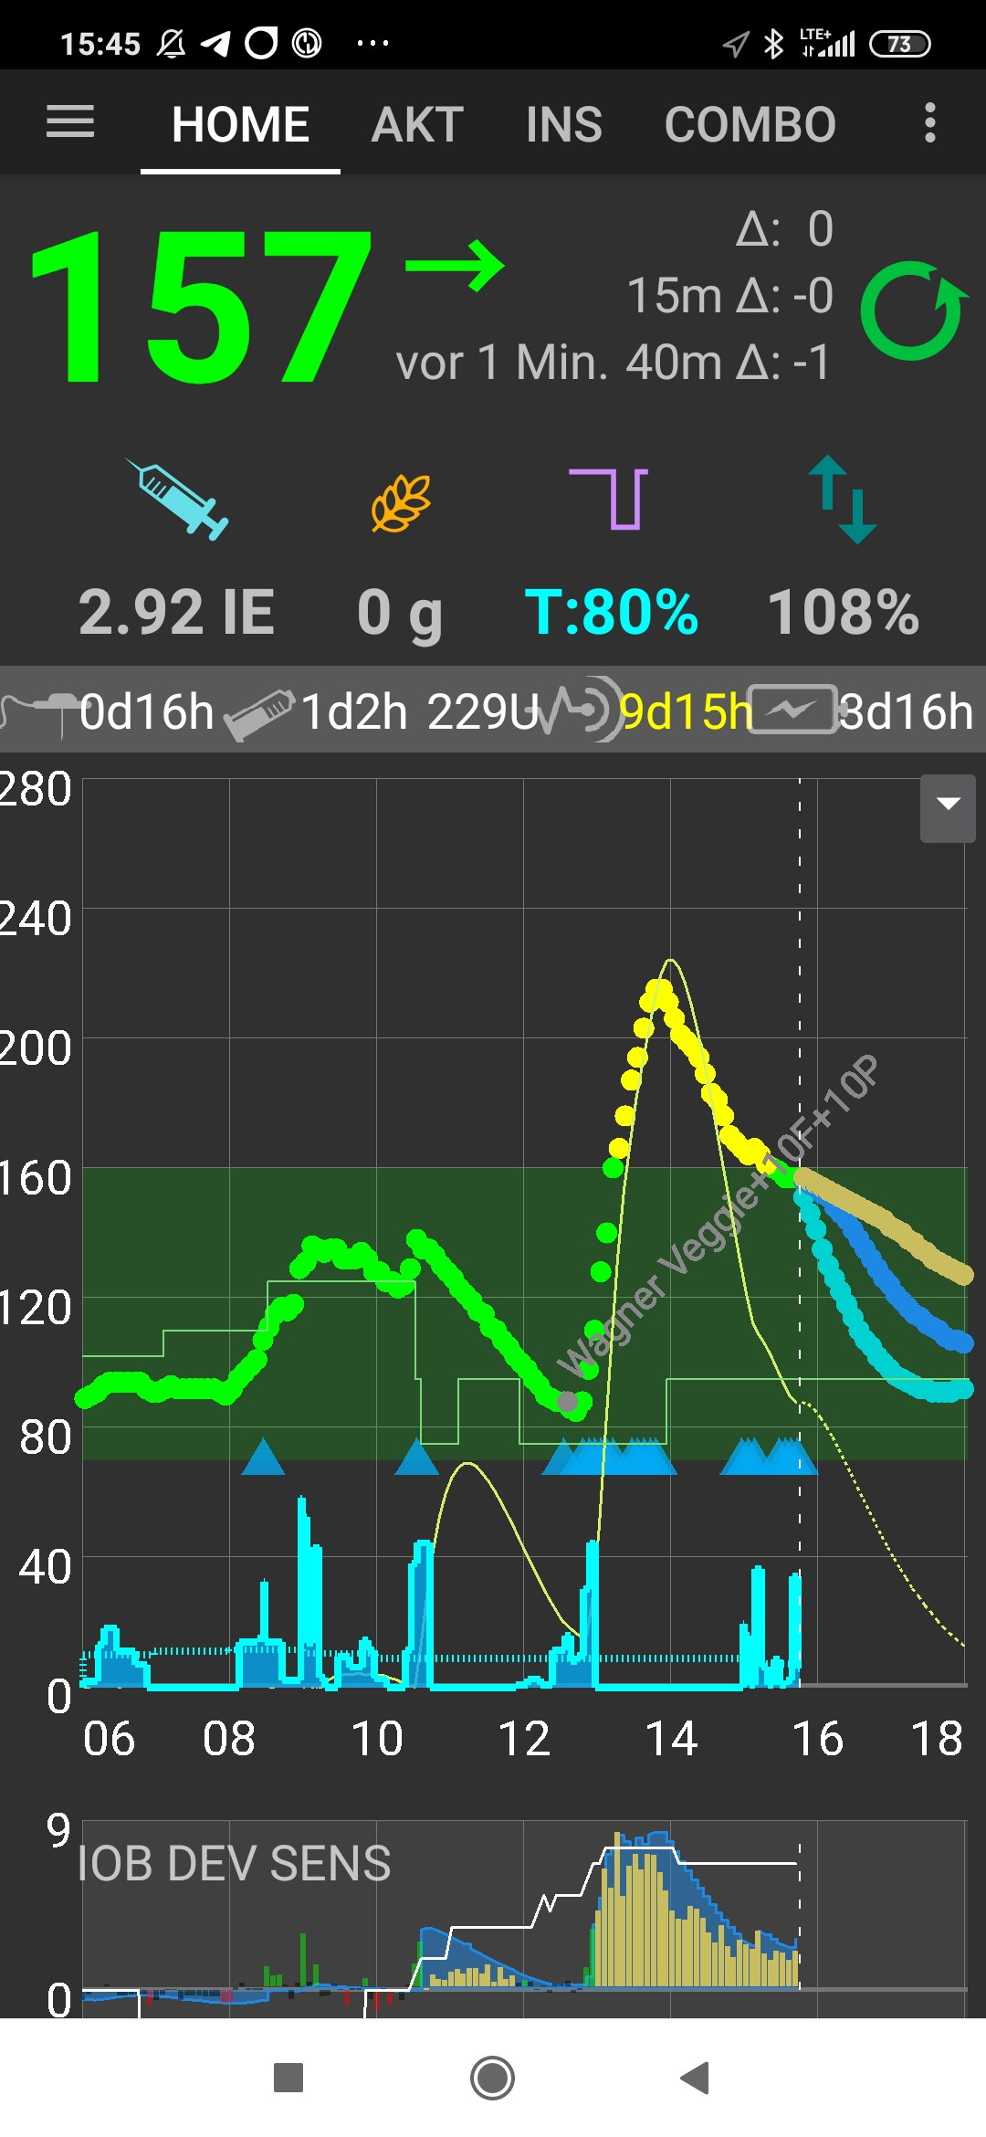

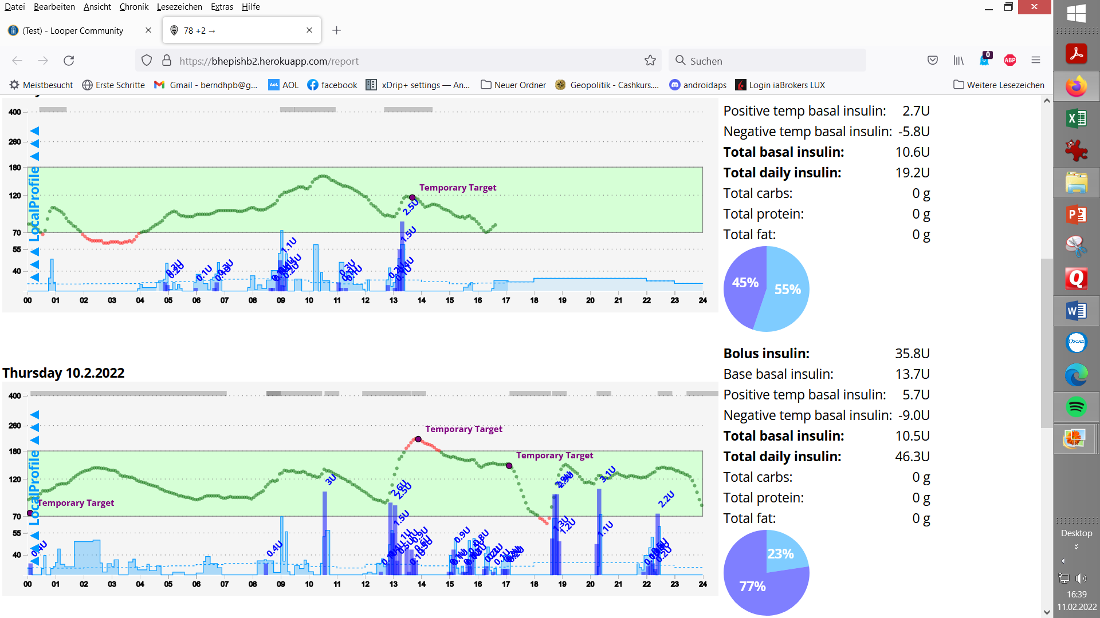

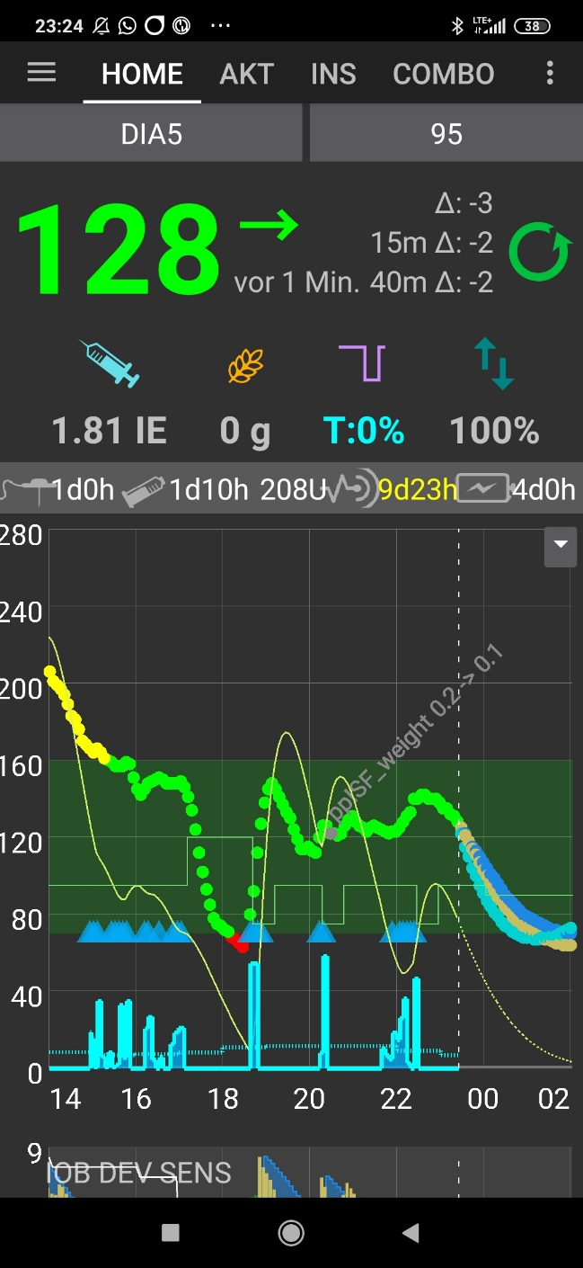

After 05:30 PM (17:30) glucose sinks a bit too fast because a dogwalk coinciding with the „tail activity“ from the SMBs while nearly all carbs were digested

How to improve settings: Analysis using the Emulator

Primary goal would be to limit the initial bg rise. But also the hypo tendency in the end is worrysome, and certainly should not increase further.

bgAccelISF_weight drives the first SMBs that are best suited to limit initial rises of bg after meal start.

Limiting the peak height is also a good means to reduce hypo danger. Moreover, hypo danger very often emanates from „over“-treating either high bg level (bgISF_weight) or duration (duraISF_weight).

Lowering iobTH could be another measure against going low. However, we have seen the need for a high iob initially (when diet includes high carb foods).

A look into the effects of all the autoISF categories (and the underlying respective _weights) should help coming to a hypothesis, how to shift weights for desired improvement.

In the following table (note: it is based on an older emulator and autoISF vesrion):

* yellow markings: where stronger SMBs (lower resulting „ISF emul“)
* red markings, where weaker or no SMBs (higher „ISF emul“) would be desired

Findings:

* Autosense (grey: AS orig => ISF AS) is not helful and should be switched off
* delta_ISF_weight seems way too strong and leads to lowered ISFs in times when we would like to reduce SMBs already (red marked, W 14-23). Moreover, delta_ISF is responsible in lines 42 und 50 for an extra of 1.7 U that contributes to going low in the end oft he investigated meal time window.
* Above the blue line (line 15, 13:02 MEZ, 12:02 Z) we minimum like to retain the sizes of SMBs. As we like to take down the delta_ISF contributions, for keeping insulin supply for W12-15, we then must shrpen accel_ISF (and autoISF_max). To retain the SMB size like in AD12-15, an emulierterated ISF as in Y12-15 must result, with help from a lowered accel_ISF (X12-15).

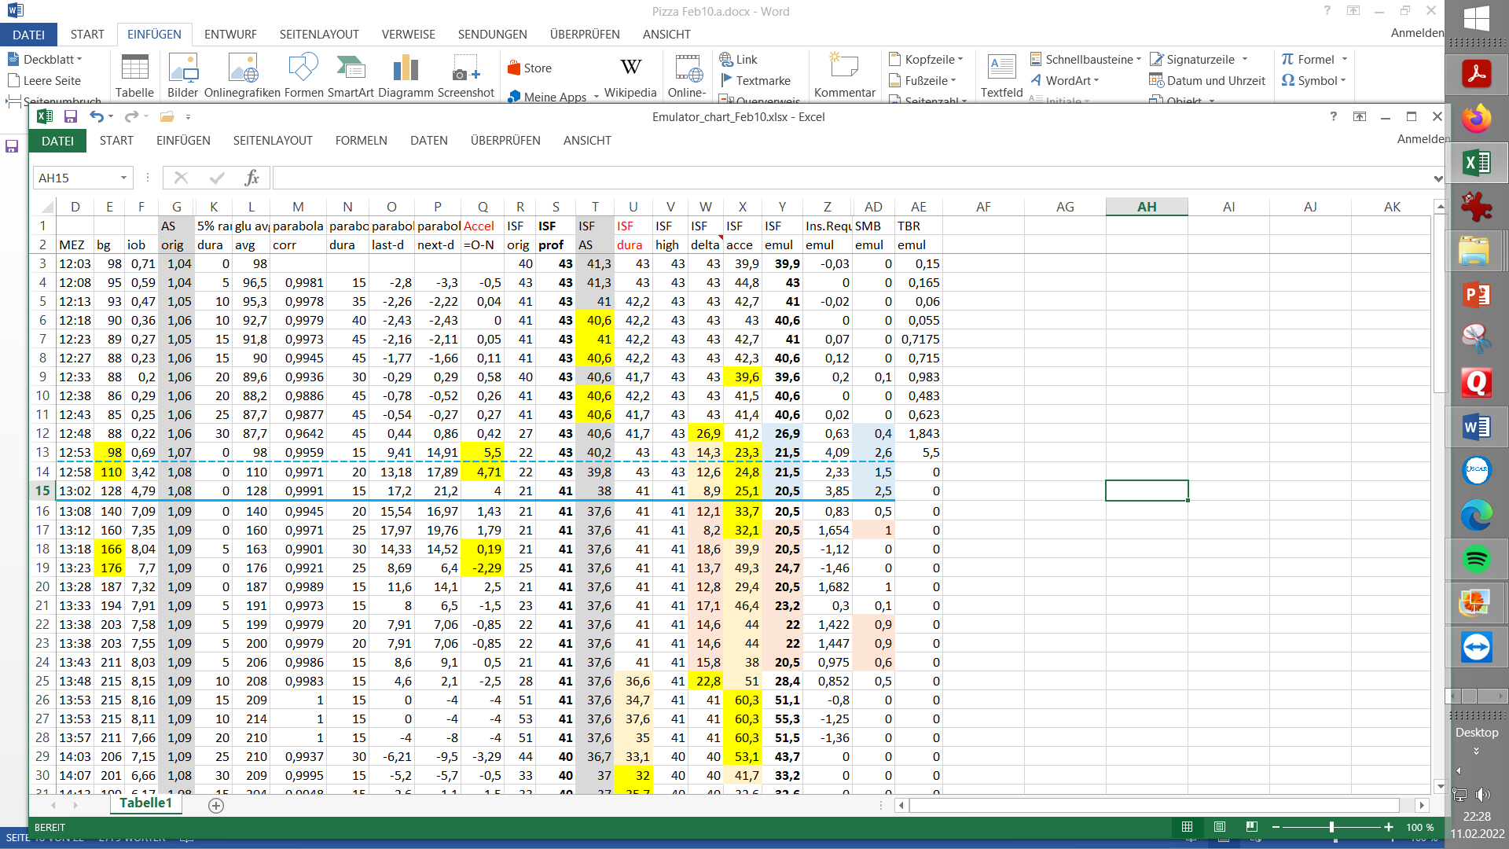

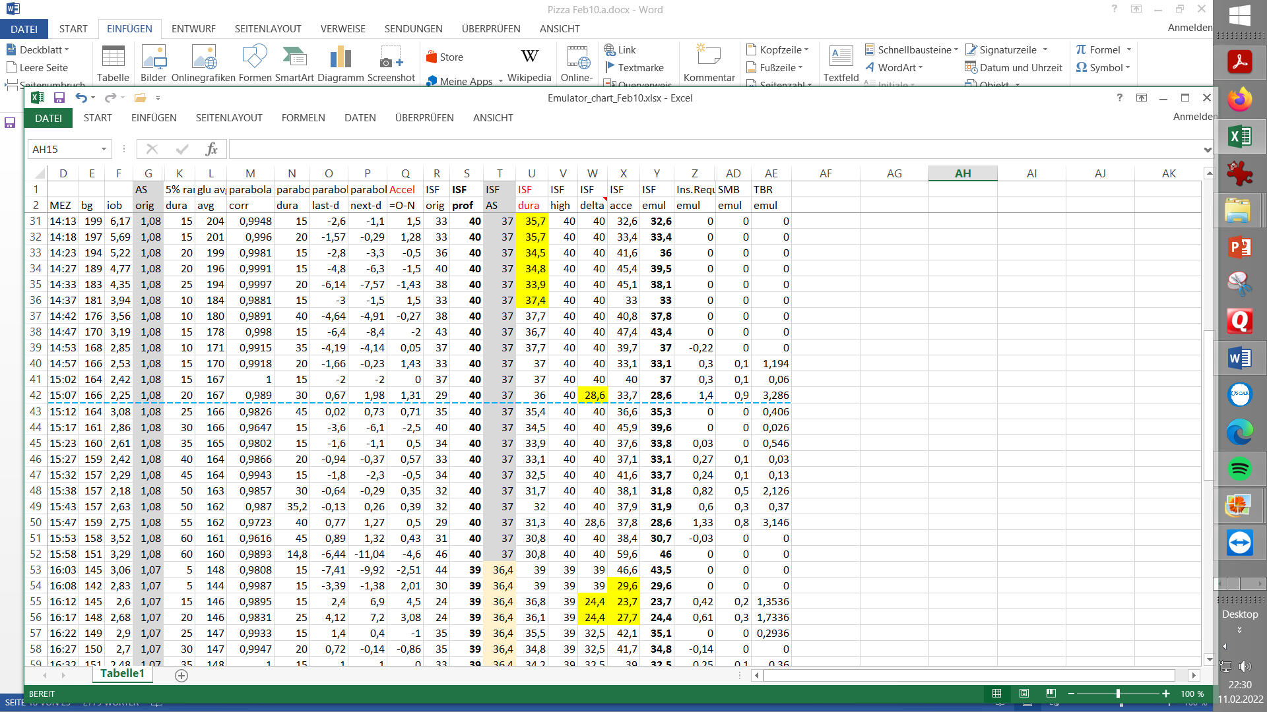

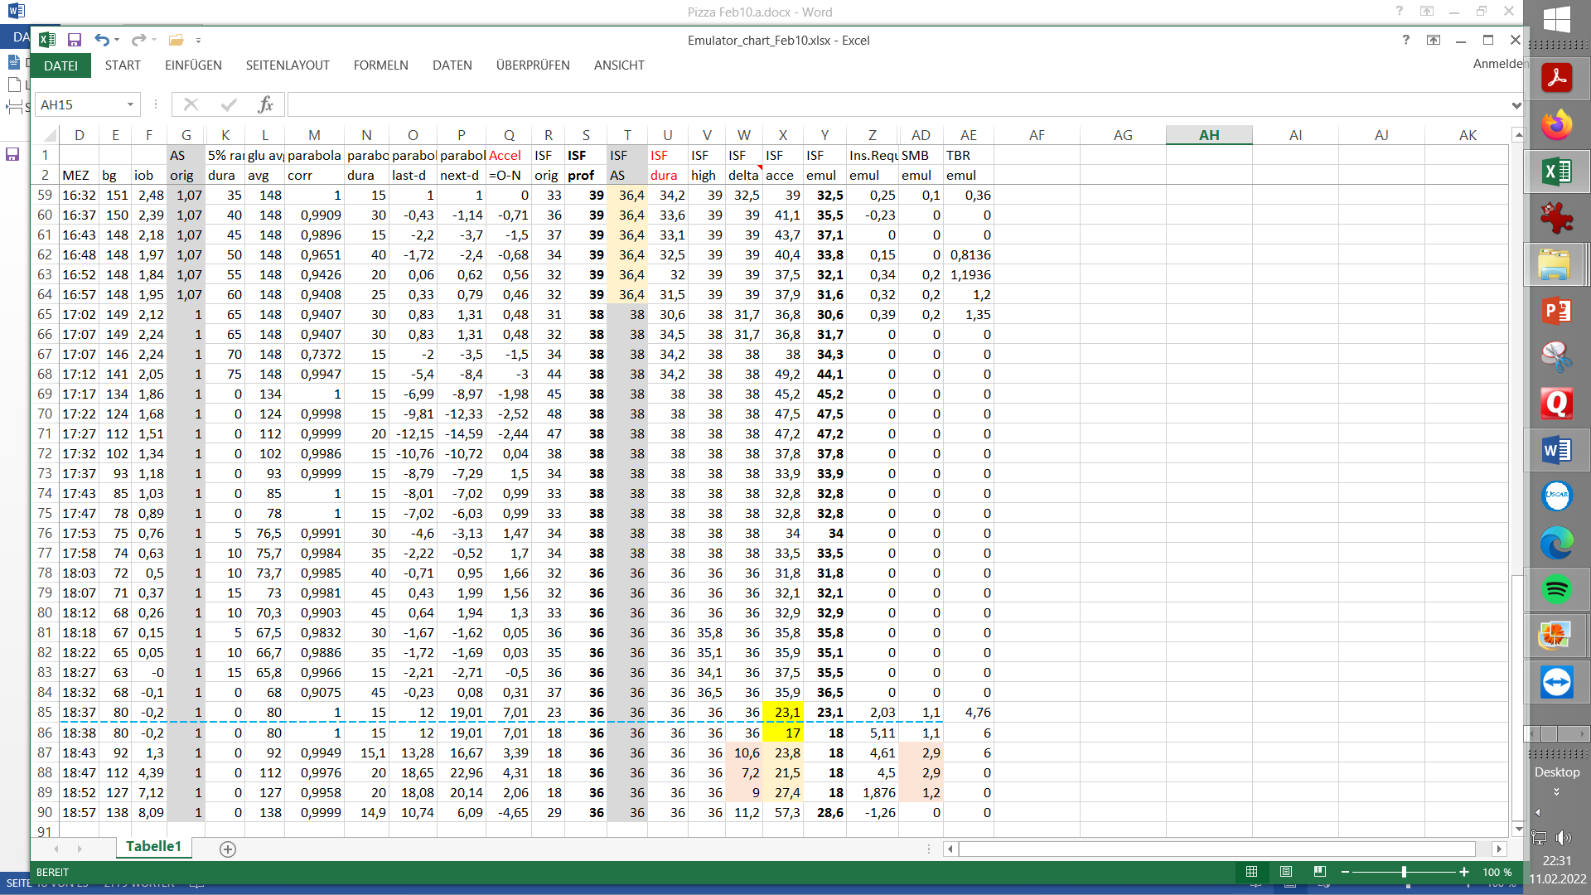

(Around 18:30h is start of next meal)

Resulting tuning

Autosense interference is not helpful and will be shut off

bgAccel_ISF_weight 0.16 is responsible fort he early SMB sizes. It will be sharpened to 0.20, considering that some delta_ISF contribution will be reduced also in this phase. .

bgBrake_weight will be slightly elevated 0.08 ->.0.11

max_autoISF is elevated from 2 to 2.5 erhöht.. min_autoISF_ratio goes 0.5 to 0.4

delta_ISF_weight ( 0.8) is reduced to 0.6

pp-ISF_weight showed over long stretches a too strong lowering of ISF. It gets strongly reduced from 0.1 -> 0.02.

This measure was cross-checked using the emultor, see next graph: ,

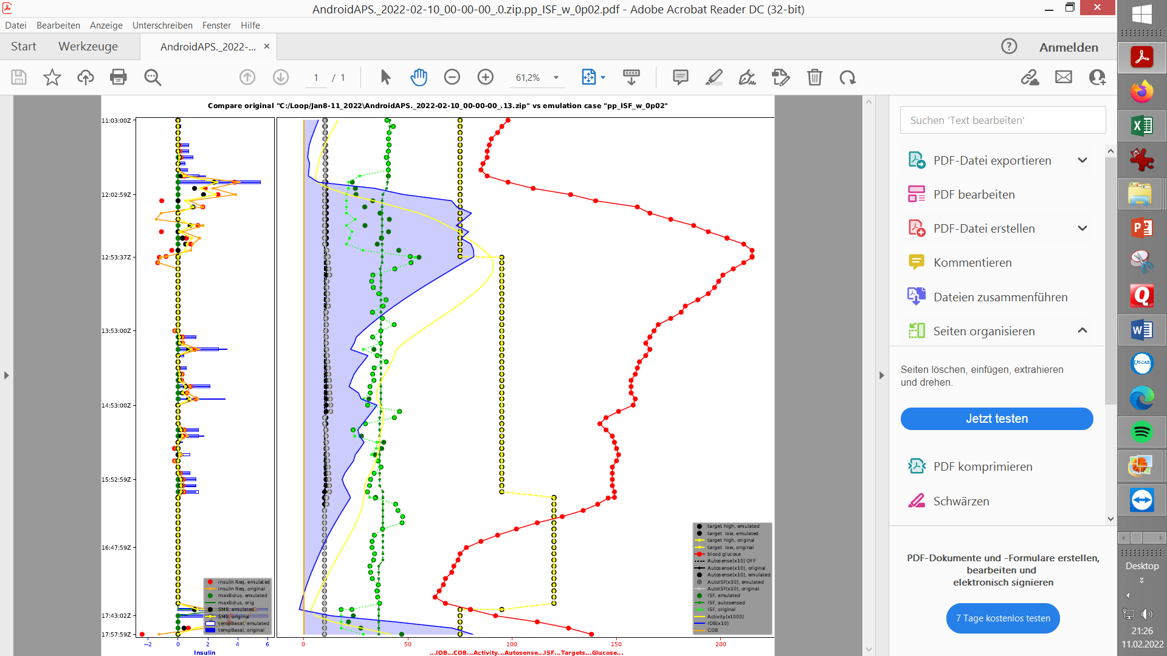

Investigating effect of reduced pp_ISF_weight (0.02, dark green points) vs. past setting (light green: ISF with 0.1 value) using the d.b. emulator:

In the mid and late stage of rising glucose, there would be an effect of lower insulin given.

Also after the max., there a a couple of instances where glucose jumps up briefly, and less insulin would be given with the reduced setting.